

Globsyn Finishing School

|  |
| --- |
| Adarsh Mohata | Ashish Kedia | Nikhil Anand |





Android Application Project

|  |  |
| --- | --- |
|  | Account Tracker |

Account Tracker Android Application

Space for home screen screenshot

## Group Members:

|  |  |  |
| --- | --- | --- |
| Name | Affiliation | Reg No |
| Ashish Kedia | National Institute of Technology Karnataka, Surathkal | 122438 12IT14 |
| Adarsh Mohata | National Institute of Technology Karnataka, Surathkal | 122692 12IT03 |
| Nikhil Anand | Bengal Institution of Technology & Management, Shantiniketan | 11630110039 |

Index

|  |  |  |
| --- | --- | --- |
| Serial No. | Topic | Page No. |
| 1. | Acknowledgement | 3 |
| 2. | Introduction | 4 |
| 3. | Target Audience | 5 |
| 4. | Requirement Specifications | 6 |
| 5. | Activities | 7-9 |
| 6. | Database | 10-11 |
| 7. | Flow Diagram | 12-13 |
| 8. | Screen Shots | 14-20 |
| 9. | Improvement Scope | 21 |
| 10. | Conclusion | 22 |

Acknowledgement

This is to mention in a small way the help we got from various sources including the websites Google.com, developers.android.com, numerous online *forums. We were also helped by a book “Android Developer’s Cookbook” by James Steele Nelson. We would like to extend our sincere thanks to our trainer & teacher Mr. Arnab Chakraborty for his immensely helpful guidance, care and support. Last but not the least we would always be grateful to Globsyn Finishing School for providing us with all the necessary tools and infrastructure. The GFS community of GLOBSYN SKILLS also motivated us to produce a successful project.*

Introduction

Account tracker is a personal finance utility app to help you maintain your expenditure and monitors balances across your multiple accounts from different banks. It helps you keep track of your accounts in an effective way.

Key Feature

* List of bank accounts
* Adding a new bank account
* Updating an existing bank account
* Deleting a bank account
* List of transactions related to a bank account
* List of recent 10 transaction from all accounts
* Search transaction by date and amount
* Showing all details of a single transaction
* Deleting a transaction

Target Audience

This app targets real life problem of carrying a number of bank passbooks and records. This app let you keep all the records in your phone instead which you can access anytime you want. With this app you can keep and update information of your various bank account, its interactive and easy. This is also very easy for accessing your information from the database. This application is targeted towards people from all spheres who have difficulty in keeping a track of their accounts which often leads to chaos and sometimes even heavy fines.

Requirement Specification

* Domain description

Account tracker is a personal finance utility app to help you maintain your expenditure and monitors balances across your multiple accounts from different banks.

* Problem Definition

Account tracker is an app that keeps the user updated of all his account and also monitors the balance, expenditures, withdraws, etc.

* System Requirements
* An Android Smartphone
* Less than 3 MB space on memory card
* 256 MB RAM
* Android version 2.2(Froyo) or above

Activities

# *Main Page or Home Page*

# *Adding New Account*

# *List of all the accounts*

# *Insert Transactions in a Particular Account*

# *View Transactions of a Particular Account*

# *Details of an Account*

# *Delete an Account*

# *Searching for a particular transaction*

# *Search by Date*

# *Search by Transaction Id*

# *List of the recent transaction*

# *Information*

Activity Details

Home Screen

This is the main activity. It consists of links to all other activities. User can choose the desire option here by clicking on the appropriate buttons and he/she will be redirected to the proper activity accordingly.

Adding New Account in the app

This is one of the primary steps in which you can add a new account in this app, after that it is saved in database for further keeping a track of all the transaction related to this particular account. You would find an icon for adding a new account in the home screen. As soon as the icon is pressed an activity starts that will take you to a new window containing all the fields with information related to your new account. You can add as many accounts as you like, as soon as you press the submit button your account is added in the list of accounts.

List of all the Accounts

As the name suggests it keeps a list of all the accounts that are registered by user. As soon as a new account is created by the user it is added in the list of account. From this page a number of tasks can be performed on a single account like we can see all the details of a particular transaction. We can also update details of the account, we can delete it and most importantly we can add transactions to that account.

Searching Transactions

This is an important activity that searches a list of transaction according to parameters fed in the search menu. The parameter can be date or amounts. For example: you can search for all the transactions between 4th July 2013 to 7th July 2013. By this you get a list of all the transactions with the accounts they are associated with.

Recent Transaction

This is another very impressive feature of this app. As soon as the app start and the recent activity button is pressed, you can see the list of last ten transaction that you have fed in your app. You can also update or delete any of the transaction.

Database

The main objective of this project is to store and keep track of user’s accounts and this is achieved by using the SQLite Database. There is only a single database used in this project containing 2 tables. Both the tables have Account No as the common attribute which helps in linking the entries of both the table.

|  |  |  |
| --- | --- | --- |
| Table Name | Attributes | Functionality |
| Account_Details | Account No, Date Of Opening, Type, Bank Name, Branch Name, Branch PhoneNo, Branch Fax No, IFSC code, Clear Balance, Unclear Balance | All the necessary details of a particular account along with all the accounts. |
| Transaction | Transaction Id, Account No, Date , Time, Mode, Type, Amount, Reference No | All the details of a particular transactions and list of all the transactions made. |

Screen Shot of Databases:

# Account Details Table:

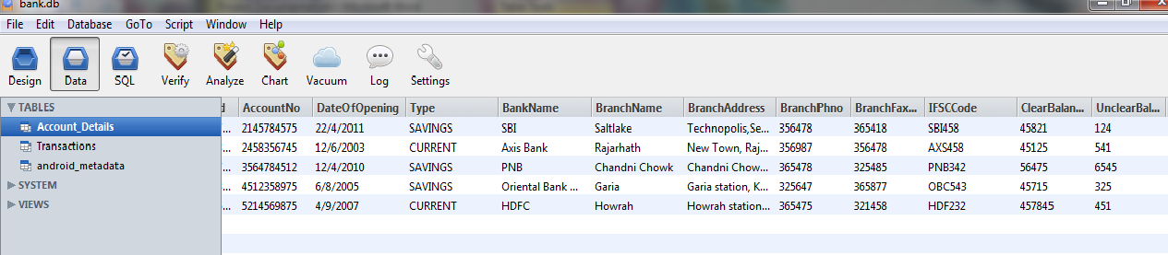

# Transaction Table:

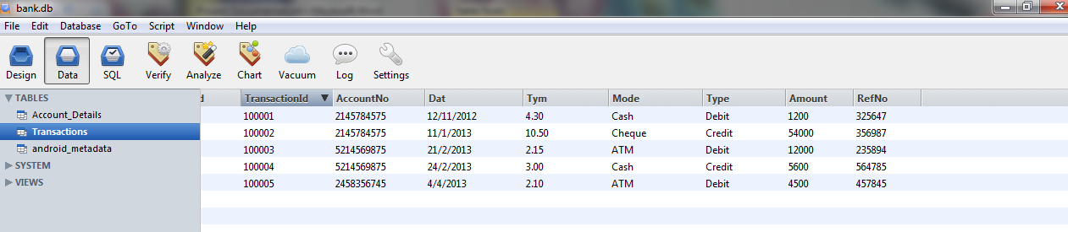

Dataflow Diagrams

Overview of Activities

Flow diagram for Adding an account

Flow diagram for List of all the Accounts

Flow diagram for searching A Transaction in Database

Screen Shots

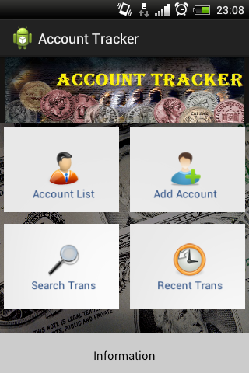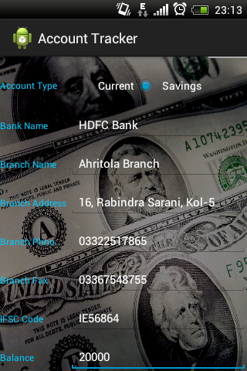

**Add Account**

**Home Activity**

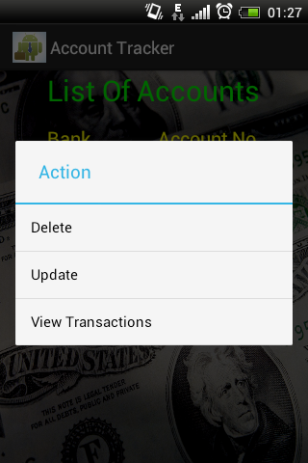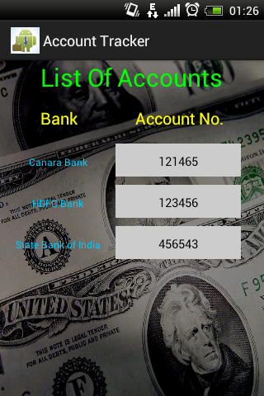

**Action Menu**

**List of Accounts**

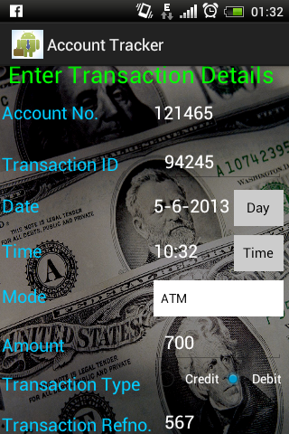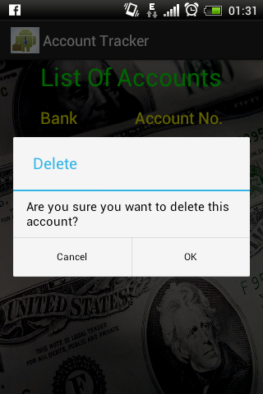

**Add Transaction**

**Delete Account**

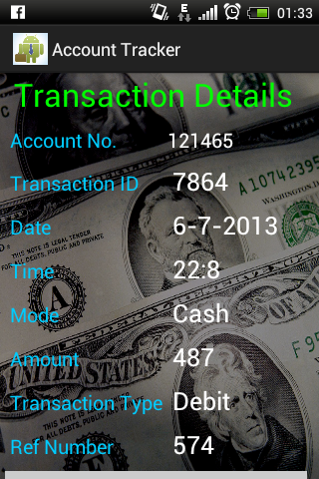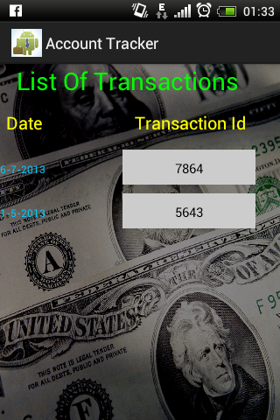

**Transaction Details**

**List of Account’s Transaction**

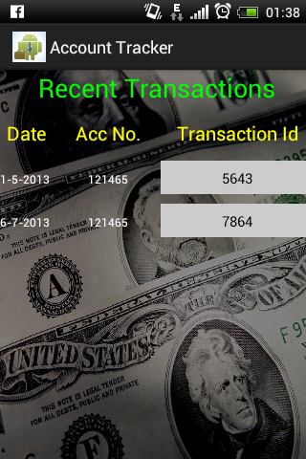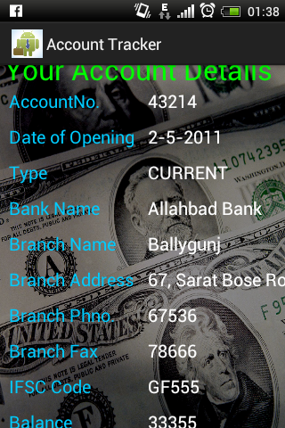

**Recent Transactions**

**Account Details**

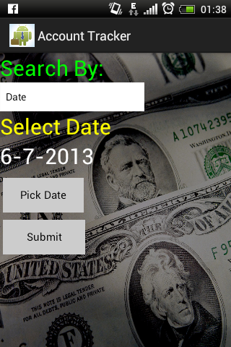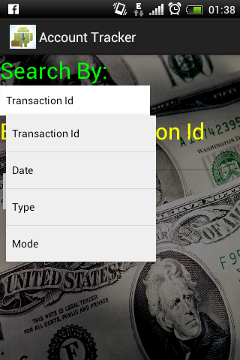

**Search By**

**Search Criteria**

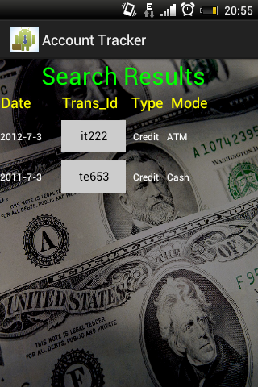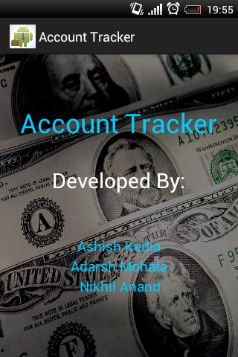

**Information**

**Search Results**

Future Scope of Improvement

In later version this app would try to update the record autonomously through connecting this app through internet banking. Also this app would provide a platform for making transaction using this app if bank jurisdictions allows. It can also fuse the particular apps provided from different banks into one, thus providing a greater platform for tracking and managing your accounts.

Conclusion

***This was a small attempt from our side to create a prototype of a system, vital nowadays in everyone’s life. In spite of its drawbacks, hope it will serve the people upto a certain extent and on our side we shall try to enhance the system for the betterment of society.***

***Thank you!!***